
FAQ 二：Polyurethane Foam as usually with is 750ML of each bottle to appear on the market but price is not the same, the same gross weight the price is different also, how to determine its quality and how to choose can meet the requirements of their own and relatively low price products?
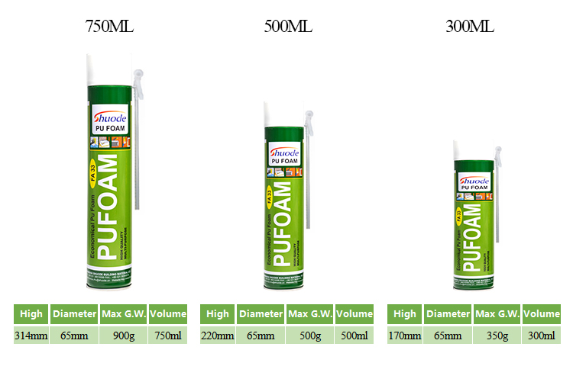
There are generally two kinds of capacity of pu foam on the market:500ML and 750ML,But many consumers and dealers,do not understood a problem.In fact, the pu foam price is calculated by gross weigh.The 500ML have 350g and 500g. The 750ML have 550g,600g,700g,750g,800g,850g,900g.So we must ask how many grams when we buy,Lest some dealers charge more with less grams.
when choose and buy, for dealers, depends on their own model is mainly wholesale, or terminal Windows and doors factory and engineering is given priority to, if is wholesale, can choose some mid-range products, relative prices have certain advantages, if is doing in terminal Windows and doors factory or engineering is given priority to, so we suggest big grams, high expansion, the relatively high cost performance products.If it is only used for general sealing, it is good to choose common type products.

