
FAQ九：How to use pu foam in winter？
一、The low temperature environment in winter will lead to the increase of the viscosity of pu foam materials，The spray gas in the bottle is not easy to vaporize and the pressure in the bottle is decreased，if the worker does not fully shake the pu foam during use.It is easy to have the problem that the front foam is sparse, The rest foam is not smooth, even cause a problem that you can't spray out
Reason：The separation of material and gas occurs during the storage of pu foam,The problem are the foam is small volume and sparse;The pu foam is not easy to spray out due to insufficient air pressure in the late.Our company product is 5 ℃ above construction can don't need to be preheated, as long as after fully shake can guarantee the normal construction.
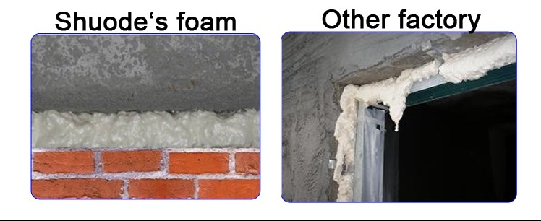
二、The normal use of foaming agent in 5 ~ 40 ℃ ambient temperature, humidity, 30 ~ 80%, stored at 5 ℃ ~ 27 ℃ temperatures.The storage environment below zero will cause the material in the tank to be frozen and the viscosity will increase. The amount of foam glue will be increasing during construction, the bubble hole will be thick, expansion will be obvious, and the foam glue is sparse.
Suggestion：construction In winter when below zero, the pu foam should be preheated before construction.
Preheating method：
- Put the pu foam in the indoor constant temperature all the night before the construction, and put it in the incubator the next day and bring it to the site for direct construction.
- 50 ℃ warm water in the preheating 5 ~ 10 minutes, shake out when construction
Note: do not use electric heating, boiling water, fire and other direct heating, so as to avoid local temperature too high tank.

