FAQ八：Instructions for use of gun and straw type polyurethane foam.
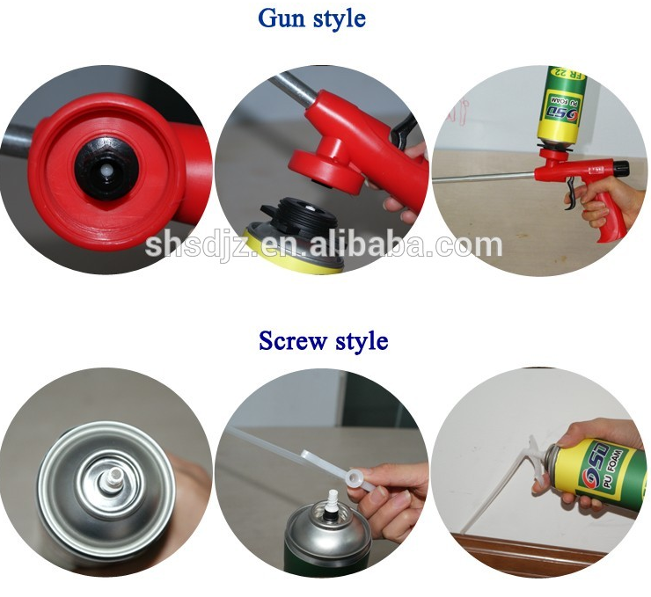
一、The advantages of gun type and straw type use.
type | 优点 | 缺点 | 适用
Gun type | 1、 The foam yield volume is one third more than the straw type，The cost is lower than the straw type  2、Adjustable the pu foam flow size to control and reduce waste. | After use needs to use the foam cleaner to clean;needs to match the special foam gun. | Suitable for large foam volume，Users with special requirements.
Straw type | its own with disposable plastic nozzle, easy to use | Cannot adjust the size of the pu foam flow, using a disposable straw, can not repeated use. | Suitable for users with low foam volume and no special requirements.

