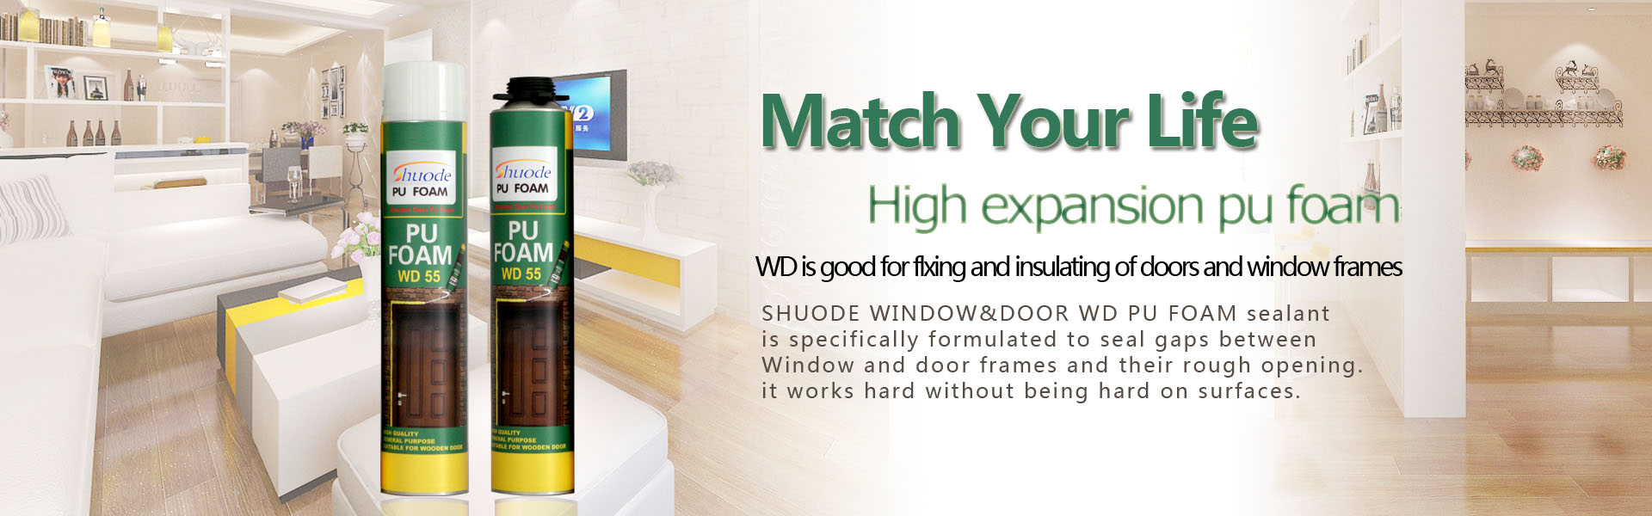
FAQ十一：What kind of pu foam is qualified?
1) The use date is within the warranty period of the product；
2) The appearance of the product is clean and all kinds of marks are clear；
3) No leakage of glue in product valves；
4) The can is not damaged and the accessories are not missing；
5) The inside liquid glue content, must be able to shake move, do not have Thickening phenomenon.

